**Table1**

1. SELECT * FROM Table1 ORDER BY [Rental Price] ASC;

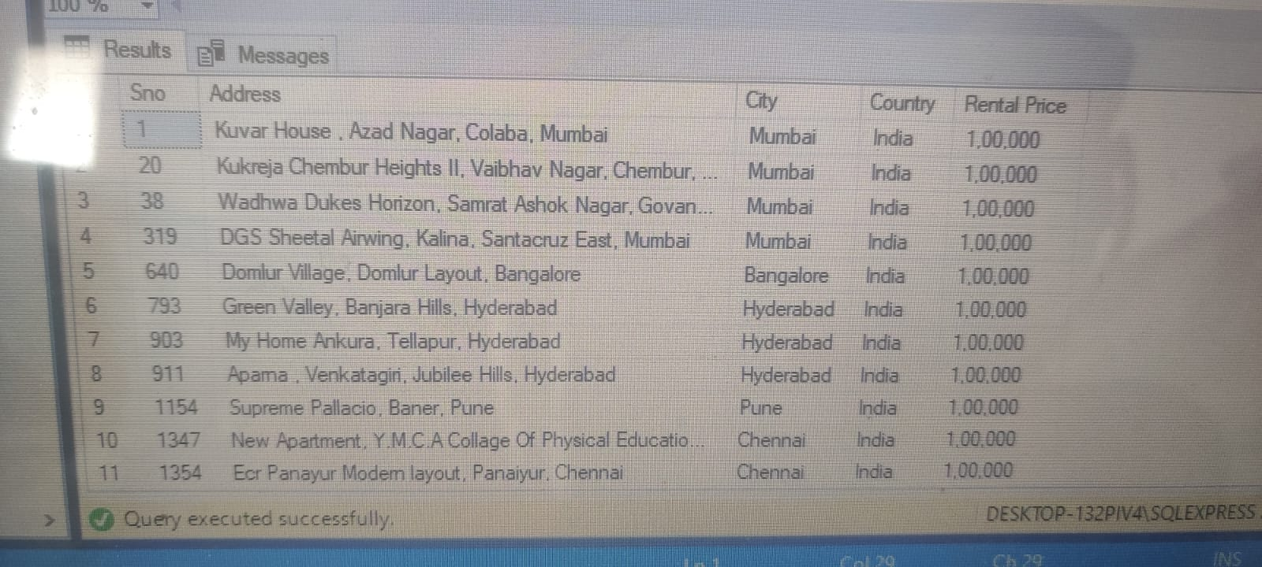

2. SELECT City, AVG([Rental Price]) AS AvgRentalPrice

FROM Table1

GROUP BY City;



3. SELECT TOP 5 Address, City, [Rental Price]

FROM Table1

ORDER BY [Rental Price] DESC;

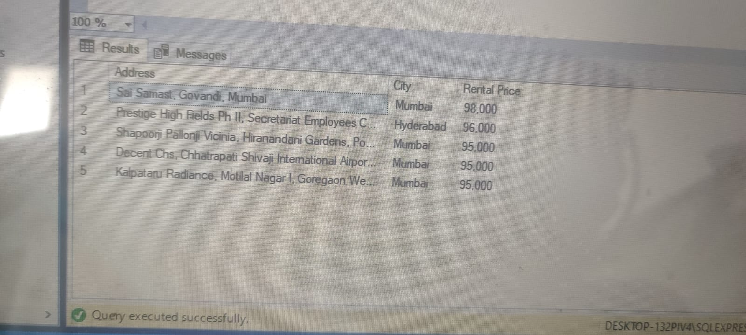

4. SELECT City, COUNT(*) AS RecordCount, SUM([Rental Price]) AS TotalPrice

FROM Table1

GROUP BY City;

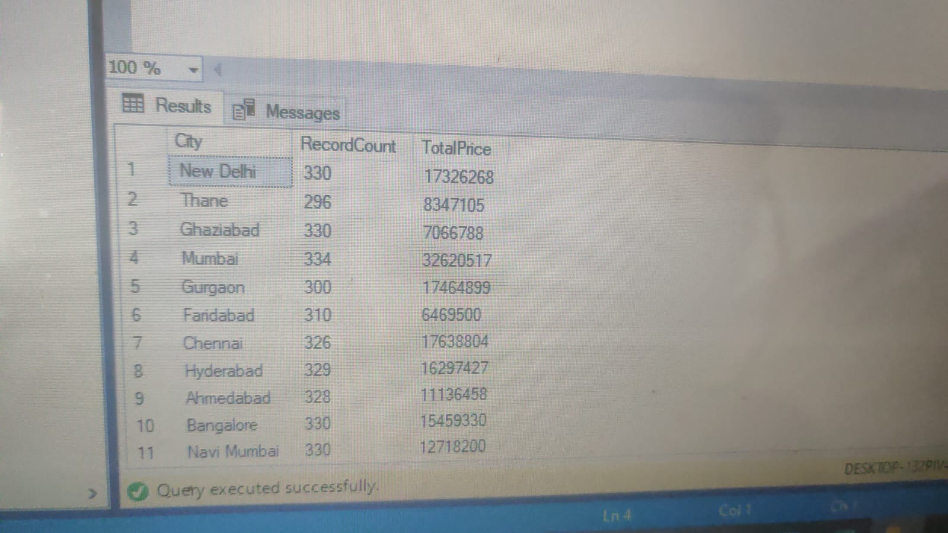

5. SELECT * FROM Table1 WHERE [Rental Price] > (SELECT AVG([Rental Price]) FROM Table1);

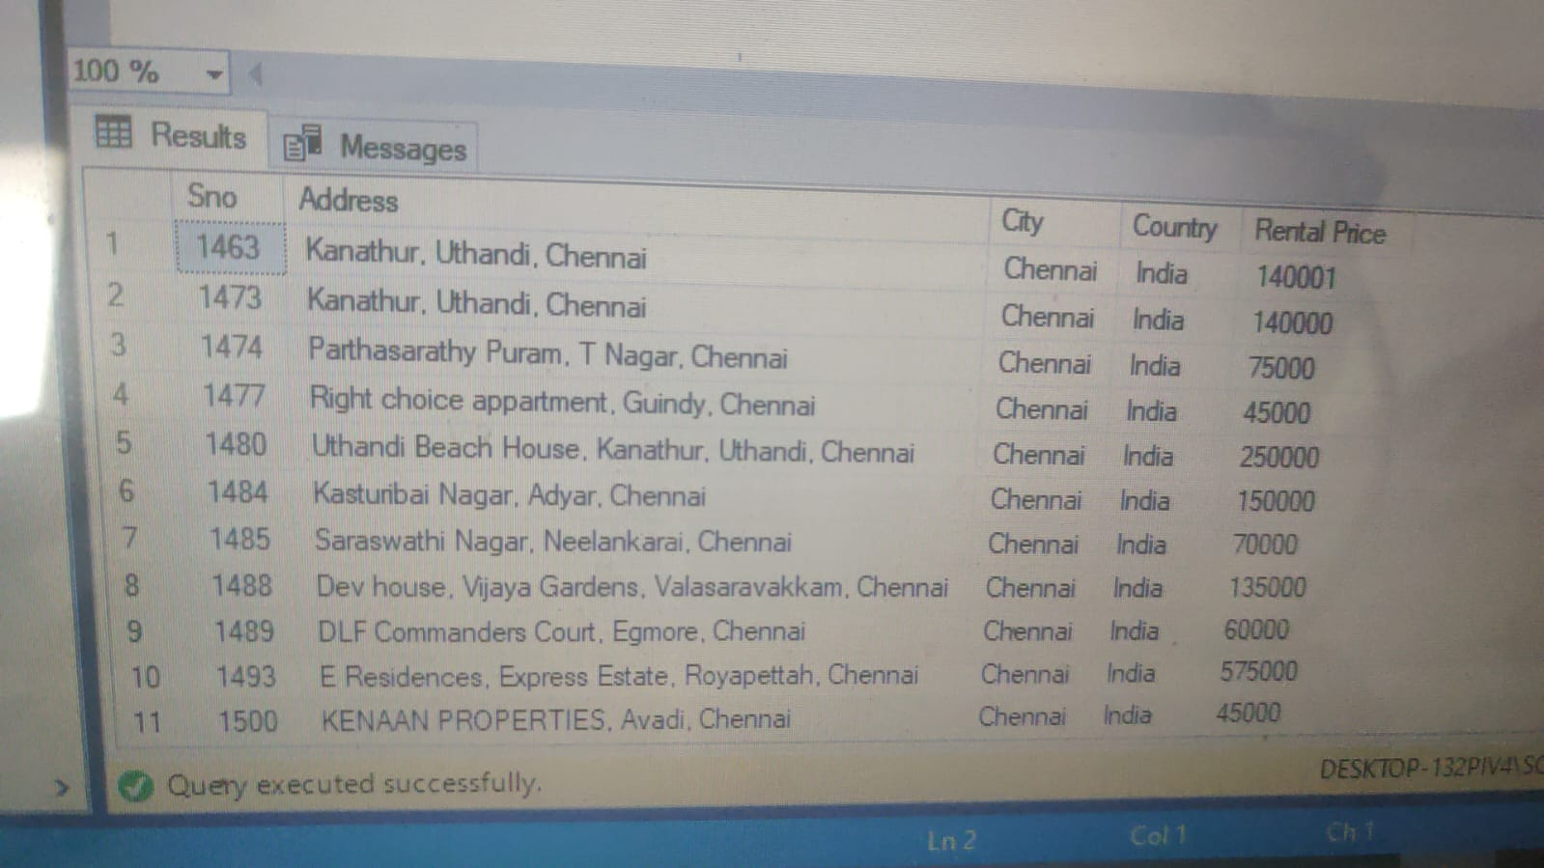

**Table2**

1.SELECT [No of Bathrooms], AVG(Area) AS AvgArea

FROM Table2

GROUP BY [No of Bathrooms];

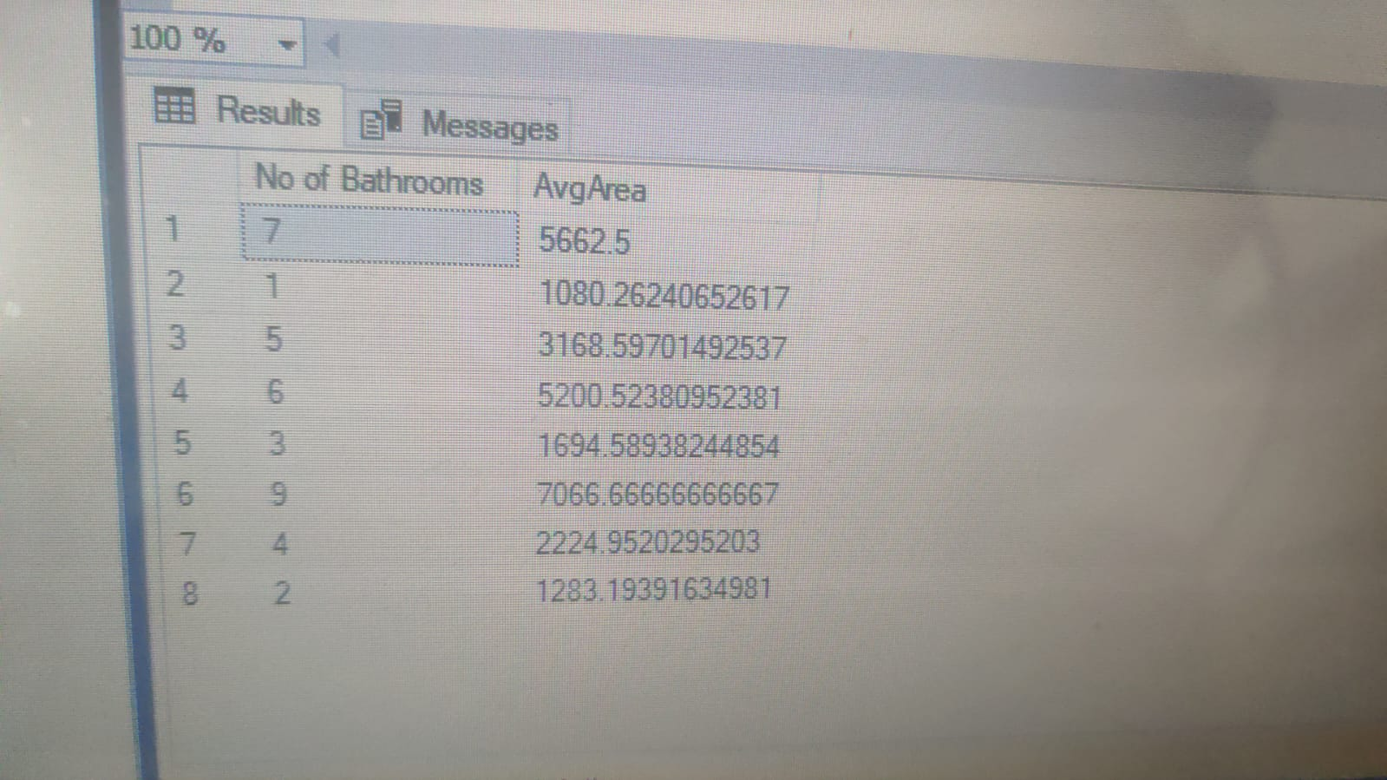

1. SELECT * FROM Table2 WHERE [No of Bathrooms] > 1 AND [Pet] = 'Allowed';



1. SELECT TOP 3 * FROM Table2 ORDER BY ([No of Bathrooms]) DESC;



1. SELECT [No of Bathrooms], COUNT(*) AS RecordCount

FROM Table2

GROUP BY [No of Bathrooms];

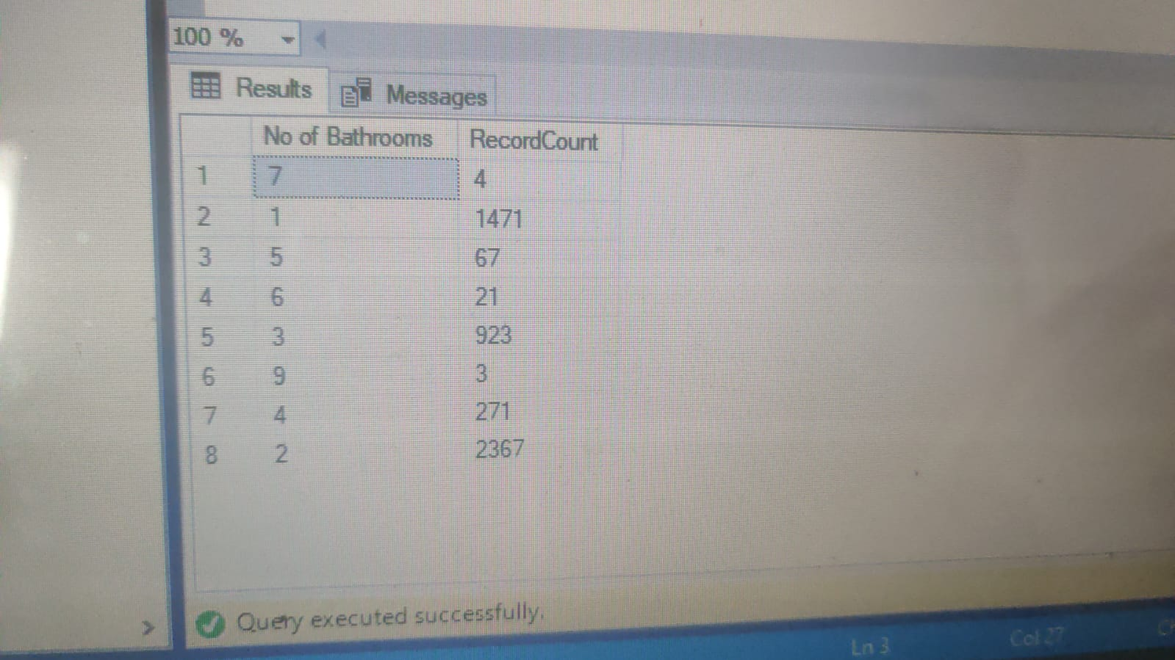

1. SELECT * FROM Table2 WHERE [Pet] = 'Allowed' ORDER BY Area DESC;

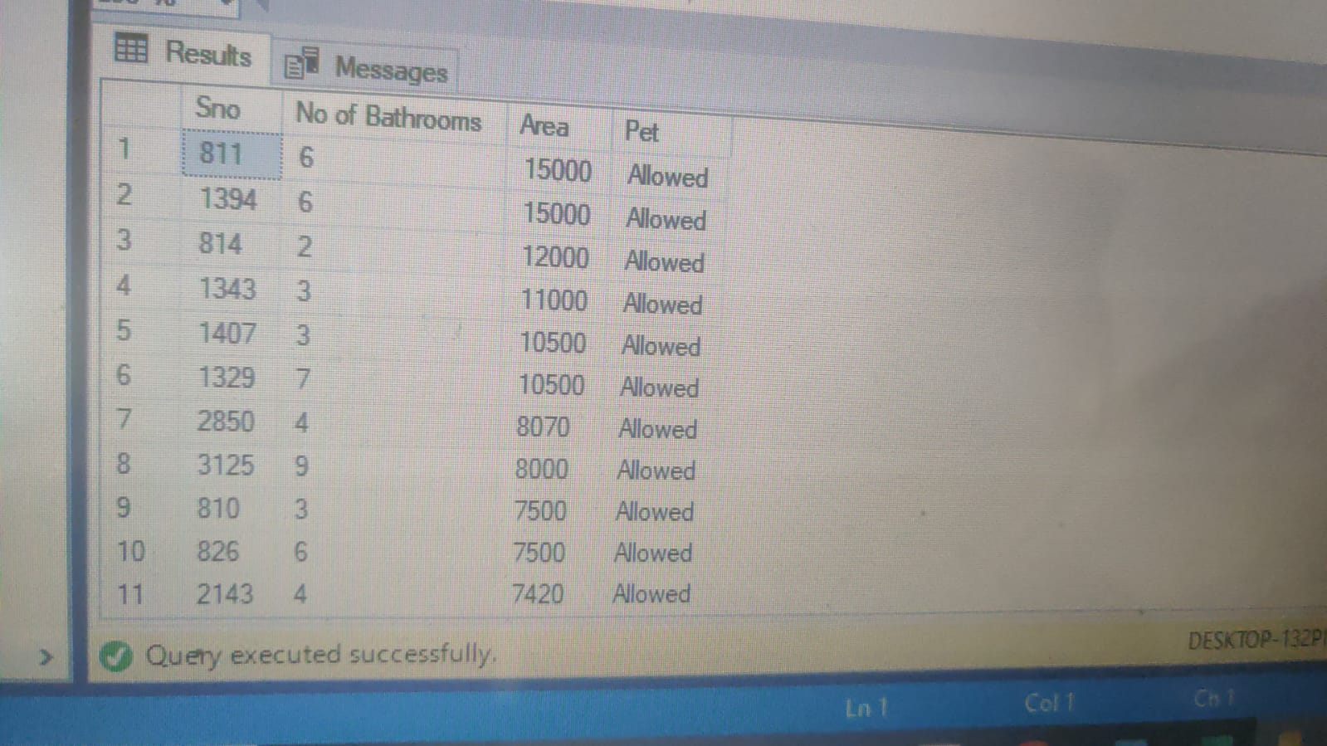

**Table3**

1. SELECT * FROM Table3 WHERE [Fridge] = 'Available' AND [Geyser] = 'Available' ORDER BY Sno;



1. SELECT * FROM Table3 WHERE [Fridge] = 'Available' AND Geyser = 'Not Available' AND Parking = 'Not Available' ORDER BY Sno DESC;



1. SELECT *

FROM Table3

WHERE [Geyser] = 'Available' AND [Parking] = 'No Parking' AND [Fridge] = 'Available'

ORDER BY Sno;

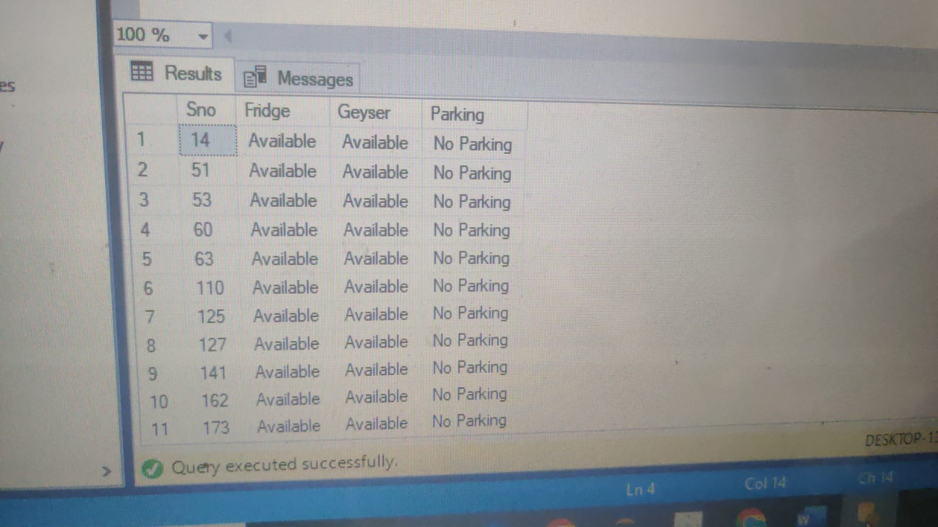

1. SELECT COUNT(*) AS RecordCount

FROM Table3

WHERE Parking = 'No Parking' AND Fridge = 'Available';



1. SELECT COUNT(*) AS RecordCount

FROM Table3

WHERE [Parking] = '1 Open Parking' AND ([Fridge] = 'Available' OR [Geyser] = 'Available');



**Join SQL Queries  using all 3 tables**

1. SELECT *

FROM Table1

WHERE Sno IN (SELECT Sno FROM Table2 WHERE Area > (SELECT AVG(Area) FROM Table2));

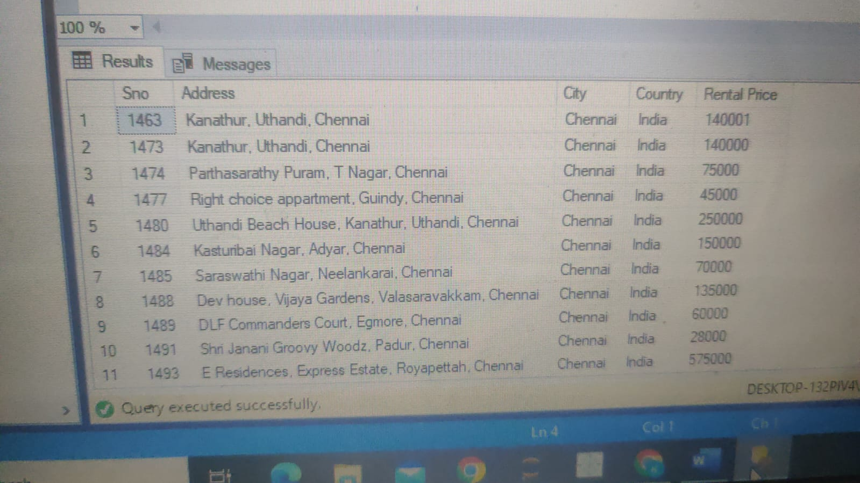

1. SELECT * FROM Table1

WHERE Sno IN (SELECT Sno FROM Table2 WHERE [Pet] = 'Allowed' AND [No of Bathrooms] > 3);

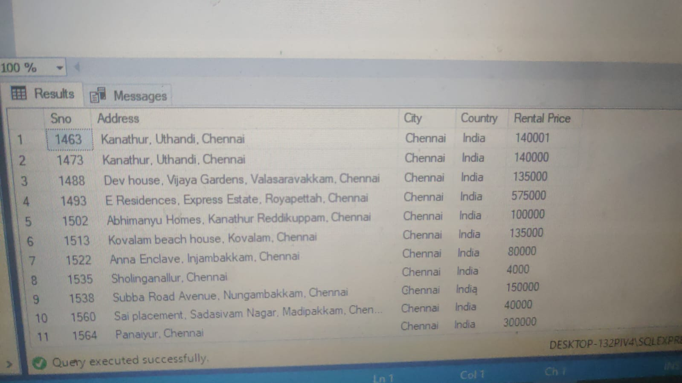

1. SELECT *

FROM Table2

WHERE [No of Bathrooms] > 2 AND Sno IN (SELECT Sno FROM Table3 WHERE Geyser = 'Available');

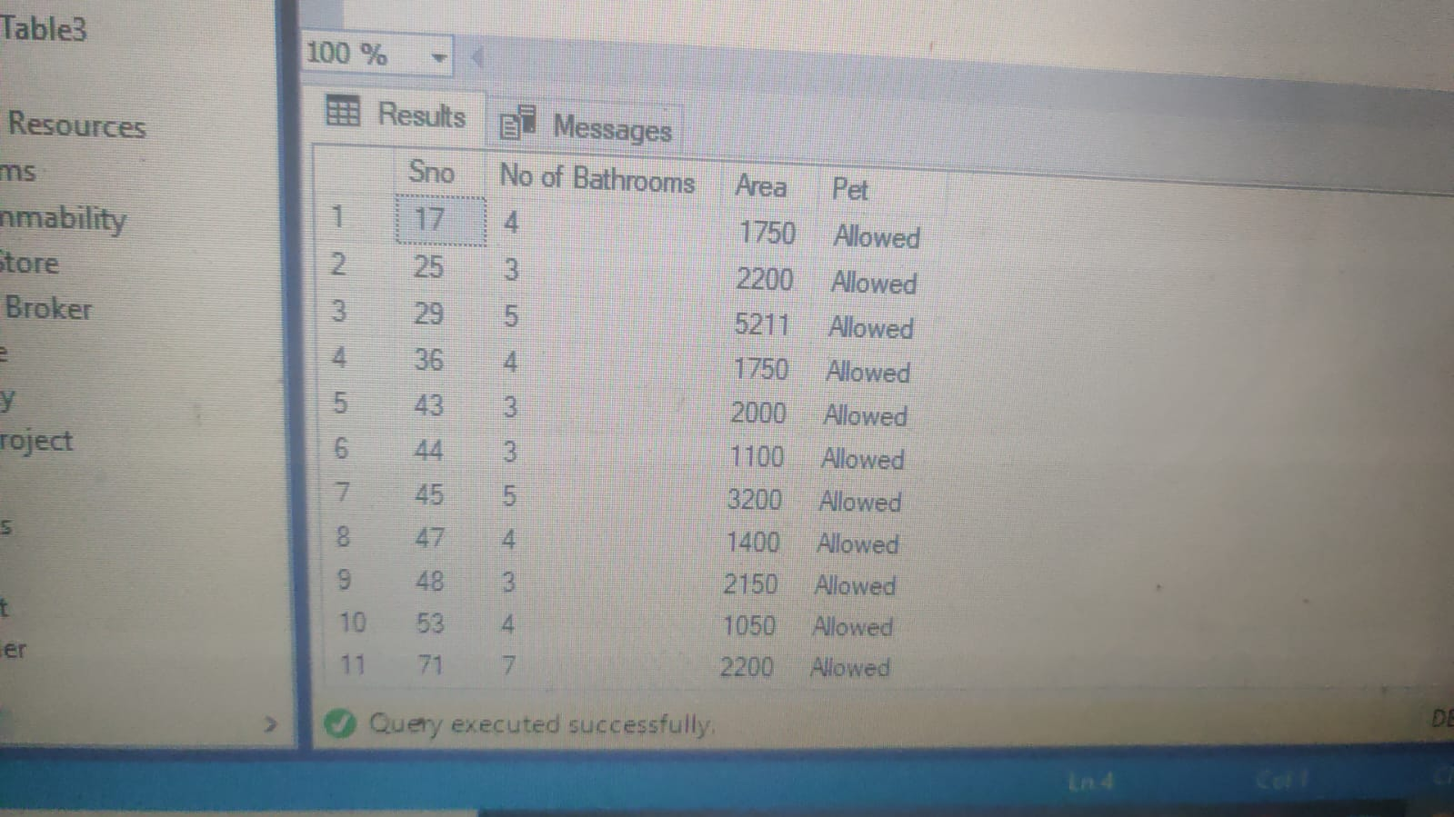

1. SELECT *

FROM Table2

WHERE [Pet] = 'Allowed' AND Sno IN (SELECT Sno FROM Table3 WHERE [Fridge] = 'Available');

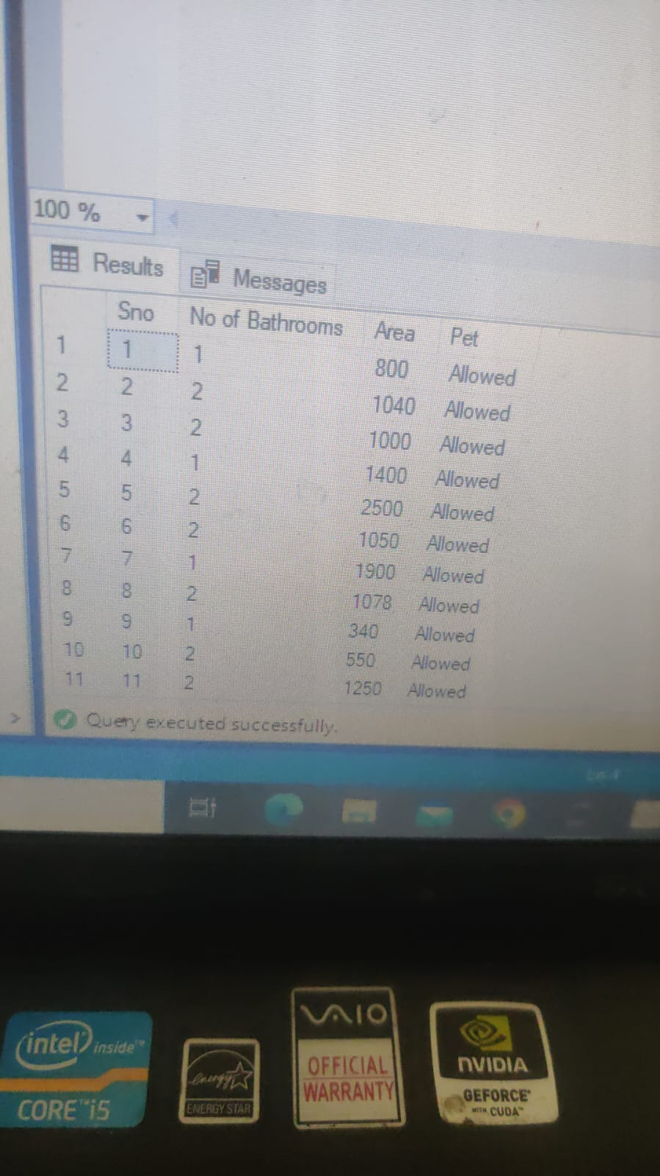

1. SELECT TOP 1 *

FROM Table2

WHERE Sno IN (SELECT Sno FROM Table3 WHERE Fridge = 'Available')

ORDER BY Area DESC;

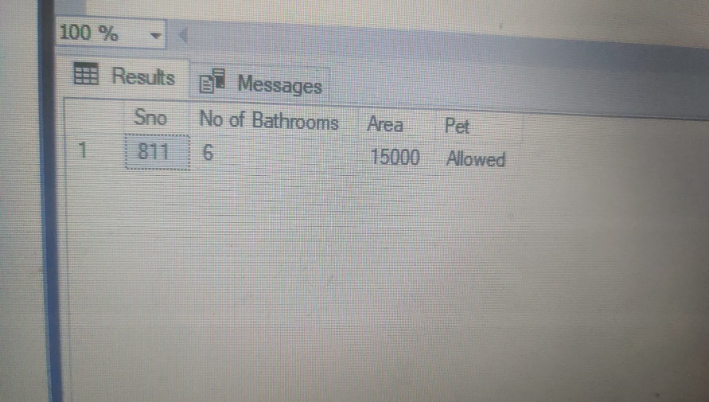

1. SELECT *

FROM Table1

INNER JOIN Table2 ON Table1.Sno = Table2.Sno;

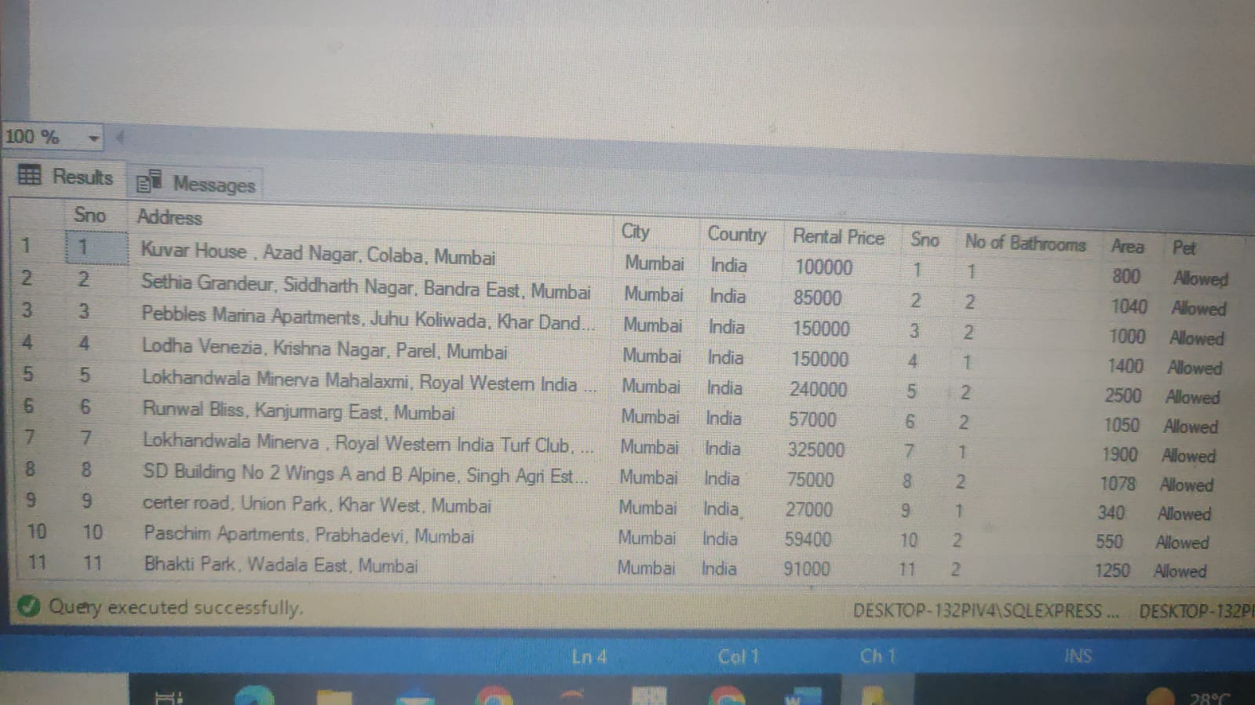

1. SELECT *

FROM Table1

WHERE Sno IN (SELECT Sno FROM Table2 WHERE [Pet] = 'Allowed' AND [No of Bathrooms] = '2')

AND Sno IN (SELECT Sno FROM Table3);

